***October Good News 2022***



**Our ministry vision for the Virginia Annual Conference is *“to be disciples of Jesus Christ who are lifelong learners, who influence others to serve.”***



**From Pastor Adam**

Hello Fall!

*The grass withers, the flower fades, but the word of our God will stand forever. (Isaiah 40:8)*

*While the earth remains, seedtime and harvest, cold and heat, summer and winter, day and night, shall not cease. (Genesis 8:22)*

Every now and again I dream about early retirement somewhere tropical, with palm trees and a seemingly endless stream of sunny days. What follows quickly on that thought is a realization of how much I would miss the wonders of Fall. We are most blessed to live in Central Virginia. The winters are relatively mild and yet we see just enough snow to make our winter wonderland dreams come true. The summers are relatively temperate, and the Fall season is filled with a kaleidoscope of color. We get all the seasons. Just enough of each without too much of one or the other. With September 22 marking the first day of Fall, the season of pumpkin spice coffee and jack-o-lanterns and warm fuzzy sweaters are upon us. The change of seasons presents us will many opportunities for spiritual reflection – the apparent death of summer foliage sets the stage for the resurrection of Spring. The coolness in the air reminds us that even as the world around us changes, the faithfulness, compassion, and reliability of our God remains steadfast. The changing rhythms of the earth reminds us that God wills this project of the human experience to continue and flourish throughout the passage of time. The arrival of Fall demonstrates the artfulness, majesty, and rationality of the creation and our Creator. May this Fall season bring us new spiritual reflection and vitality. May our hearts lift up to God and to one another more and more with each passing day.

God bless you my friends, Adam

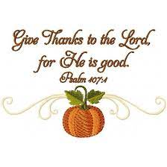

**World Communion Offering**

We will collect this offering on Sunday, October 16th.This is a special offering to support young adults and make a global impact for Christ. Half of the offering benefits World Communion scholarships for graduate students from the U.S. and other countries. The remainder assists Ethnic Scholarships for U.S. and international undergraduate students in the U.S. and Ethnic In-Service Training. These funds are administered by the General Boards of Higher Education and Ministry and Global Ministries. When you give generously on World Communion Sunday, you partner with talented, qualified students from around the globe to transform the world as witnesses for Christ.

**Choir News**

Check your Sunday’s bulletin for choir times and dates. Come and lend your voice. All are invited!!

~*Heather Wilson*, Director of Music

**Circle News**

* * * * * * * * * * * * * * * * * * *

The **Wesleyan Group** will meet on Monday, October 10, 2022, at 7:00 p.m., at the home of Linda Jessen (207 Dean St.).

*Mission Memo*

For September our grocery cart contained 128 lbs of canned meat, fruit, and pasta for Park View Mission food for families. Our continued support enables the mission to feed families in the city who are struggling. As always they were grateful for our faithful and continued support. Thank you to all who faithfully continue to support this mission.

For October we will continue to collect the same canned meats, fruits, and canned pasta with meat. The mission is also in need of toothpaste and deodorant for men and women.

~*Thank you the Mission Committee*

**Food Cart...**

 Items needed for the Food Cart for ***Park View Community Mission.***

For the Month of  **October**

**Canned Meat, Canned Fruit, Ravioli**

(Make sure all the cans have tab tops.)Also toothpaste and men/women deodorant**.**

*Place donations in the grocery cart, located in the Commons*. **No “*baked goods*” of any kind.** *Place donations in the grocery cart, located in the Commons*



***Charge Conference***

***Location Change***

**Mountain View District Palooza** (Annual Charge

Conference) **-- Saturday, November 5th at 9:30 am at Heritage UMC, 582 Leesville Rd., Lynchburg.**  
 (The District Office is asking for church buses or vans and offers of carpooling to transport church members to Heritage UMC. Be in touch if you can help).

*I would like to express my sincere thanks* to all of you for the many, many cards that I received on my 96th birthday (September 21). Also thank you so much for the prayers, cards, and visits that I have received during my rehab. I am a part of such a loving and caring church and I send you my love and sincere thanks. *~Beryl Martin*

**CLEANING KIT COLLECTION**

There is a special call for a Conference-wide Cleaning Kit collection.  Each District is asked to coordinate and communicate this call to the local churches.   
  
 Our district's Annual Conference Kit Coordinators will do most of the work.    
Our District Annual Conference Kit Coordinators are Rev. Ryan Ware (ryanware@vaumc.org) and  Rev. Tobias Lutz (tobiaslutz@vaumc.org) Please see the following document that will give a better idea about this event.    
  
 Serving Ministries will be committed to developing resources to support each district in making this a reality!   
  
**Special Called Cleaning Kit Plan** - [https://docs.google.com/document/d/1-W4-lyjbbK2iE3yZwTuA9ebJbz9KGSD0tvBa563oX6A/edit?usp=sharing](https://dandist.us12.list-manage.com/track/click?u=10c84b36b5e5f8cf7c502d428&id=62b7bdff25&e=b78bc3bb61)



18 Sharon

Rickmon

19 Connie Yost

20 Erin Ecklund

21 Steven Kinzer

22 C.O. Bell

25 Frankie

Hardwick

28 Jacqueline Busic

Cheryl Thomas

29 Wes Robbins

Ricky Smith

31 Robert Baunach

1 Pat Short

2 Nancy Lee

Emily V.

Fernandez

3 Michael McGlothlin

6 Kirsten Bell

Tim Crist

Dennis Tolley

7 Kenny Busic

Cheryl Powell

9 Owen Stinnette

Jeremey

VandeBogart

11 Landen Glass

12 Camden Mason

14 Wade Ware

16 Burton Brooks

Terry Palazzi

Anne-Elaine Tiller

17 Suzanne

Marshall

Blake Phillips





1 Pat Short

2 Nancy Lee

Emily V.

Fernandez

3 Michael McGlothlin

6 Kirsten Bell

Tim Crist

Dennis Tolley

7 Kenny Busic

Cheryl Powell

9 Owen Stinnette

Jeremey

VandeBogart

11 Landen Glass

12 Camden Mason

14 Wade Ware

16 Burton Brooks

Terry Palazzi

Anne-Elaine Tiller

17 Suzanne

Marshall

Blake Phillips

18 Sharon

Rickmon

19 Connie Yost

20 Erin Ecklund

21 Steven Kinzer

22 C.O. Bell

25 Frankie

Hardwick

28 Jacqueline Busic

Cheryl Thomas

29 Wes Robbins

Ricky Smith

31 Robert Baunach

**2022**

|  |  |
| --- | --- |
| **Those Who Serve~October**  **GREETERS:**  October 2 ~ Ann Robbins  October 9 ~ Maggie Musgrove  October 16 ~ Tucker Cole  October 23 ~ Jane White  October 30 ~ Mary Walker    + + + + + + + + + + + + + + + + + + + + + + +  **GOOD NEWS** is published monthly for members and friends of Chestnut Hill United Methodist Church. Send articles to the church office by the 15th of the month. **(Subject to change.)**  + + + + + + + + + + + + + + + + + + + + + + + | **Our Church Financial Picture**  Through the end of August 2022  General Operating Funds:  Needed to meet our 2022 Budget $ 194,759.00  Needed to meet our budget to date $ 129,839.00  Actual receipts to date $ 112,176.00  Shortage to meet budget to date $ 17,663.00  Actual expenditures to date $ 111,582.00  Overage to meet expenses to date $ - 594.00  Joy In Missions Funds:  Our Giving Goal for 2022 $ 11,600.00  Needed to meet our goal to date $ 7,733.00  Actual receipts to date $ 6,685.00  Special Offerings* (not budgeted):  Received to date $ 12,930.00  Dispersed to date $ 12,510.00  *Christmas, Easter, Annual Conference,  World Communion, etc.  **2022 Joy In Mission Donations**  To date, the following amounts have  been paid to the missions indicated.  Budget Spent  1. Missionary Covenant Relationship $1,000 $500  2. Interfaith Outreach $1,000 $500  3. Park View Mission, Food for  Families $3,000 $1,825  4. Society of St. Andrew $1,000 $500  1. Adult Care Center $ 500 $250  2. Blue Ridge Area Food Bank $ 1,000 $500  3. Camp Timothy $ 500 $500  4. Churches for Urban Ministry $ 500 $0  5. Daily Bread $ 500 $250  6. Free Clinic $ 500 $250  7. Good Neighbor $ 500 $0  8. Habitat for Humanity $ 500 $250  9. UMCOR-Non-Administrative $ 500 $0  10. Undesignated $ 600 $0  Thank You for Your Generosity |

**March 2022**



January 2022

**2022**



**2022**

|  |  |  |  |  |  |  |
| --- | --- | --- | --- | --- | --- | --- |
| **Sunday** | **Monday** | **Tuesday** | **Wednesday** | **Thursday** | **Friday** | **Saturday** |
|  | | | | | | **1** |
| **2 *World Communion Sunday***  9:30 am Sunday School  10:30 am Worship | **3** | **4**  6:30 pm Homeschool Game Night | **5** | **6** | **7**  **Church Office Closed**  10:00 am Homeschool | **8** |
| **9**  9:30 am Sunday School  10:30 am Worship | **10 *Columbus Day***  **Church Office Closed**  7:00 pm Wesleyan Group | **11**  6:30 pm Homeschool Game Night | **12** | **13** | **14**  10:00 am Homeschool | **15** |
| **16**  9:30 am Sunday School  10:30 am Worship-Holy Communion | **17**  5:00 pm CSE Craft Event (Camp Meadowlark) | **18**  6:00 pm Finance Committee  7:00 pm Administrative Council | **19** | **20** | **21**  10:00 am Homeschool | **22** |
| **23**  9:30 am Sunday School  10:30 am Worship | **24** | **25** | **26** | **27** | **28**  10:00 am Homeschool  6:30 pm Homeschool Fall Halloween Party | **29** |
| **30**  9:30 am Sunday School  10:30 am Worship | **31** |  | | | | |



**April 2022**

**April 2022**

**March 2022**



*Chestnut Hill United*

*Methodist Church*

4660 Fort Avenue, Lynchburg, VA 24502

Phone Number: 434-239-8423: FAX: 434-239-7209

E-mail: [chestnuthillumc@comcast.net](mailto:chestnuthillumc@comcast.net)

On the web: www.chestnuthillumc.net

Church Office Hours

**Monday-Thursday~**9:00 am—3:30 pm

**Friday~**9:00 am-1:00 pm

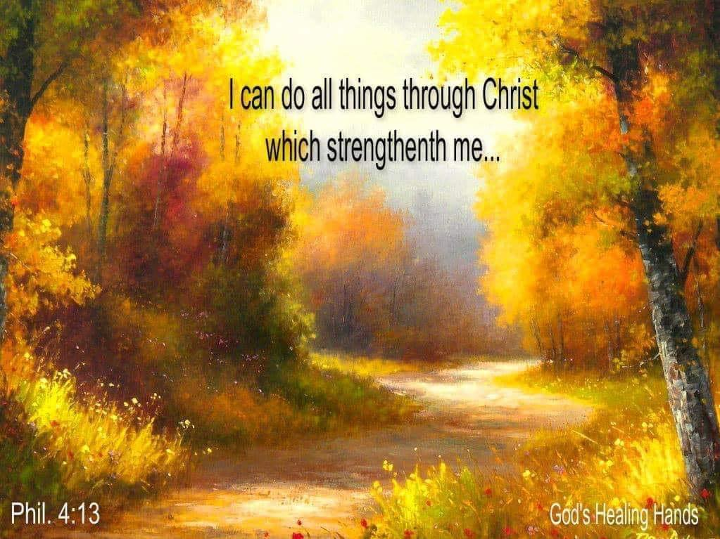

***DIRECTORY OF***

***CHESTNUT HILL UNITED METHODIST CHURCH***

|  |  |  |
| --- | --- | --- |
|  | Sharma Lewis | Richmond Area Resident Bishop |
|  | Denise Bates | Mountain View District Superintendent |
|  | Adam White | Minister |
|  | Erin Long | Associate Minister |
|  | Monica C. Campbell | Administrative Assistant |
|  | Heather Wilson | Director of Music Ministry |
|  | Judy Martin | Bookkeeper |
|  | Judy Robertson | Lay Leader |